REBECCA SLATTERY

CANCODE COMMUNITIES

SUMMER 2022

Final Project

Analysis of Nutrition Content: “Indian Menu”

Fast food has always been a center of interest for consumers and individual interested in healthy choice. One set of data collected is for specific menu items from a known fast-food chain that has a data titled under “Indian Menu”. For each item on the menu category there is listed the Total fat (g), Saturated fat (g), Trans fat (g), Cholesterols (mg), Total carbohydrate (g), Total Sugars (g), Added Sugars (g) and Sodium (mg).

By comparing a few of the burgers on the menu a customer has the option to make a food choice that better suits the individual’s needs or desires. For example, some individuals may want to choose the item with a lower total fat content, while another individual maybe wish to choose an option with less sugar content. If a customer has the desire to know the content of nutritional value of an item, they may choose an item from the menu that best suits their nutritional goals.

This study chose a few items from the menu to analyze that includes the McVeggie Burger, McAllo Tikki Burger, McSpicy Panner Burger and the Spicy Panner Wrap.

Below: This table includes the collected Nutrition content of data for the items from the Regular Menu.

|  |  |  |  |  |  |  |  |  |  |  |  |  |  |  |  |  |  |  |  |  |  |  |  |  |  |  |  |  |  |  |  |  |  |  |  |  |  |  |  |  |  |  |  |  |  |  |  |  |  |  |  |  |  |  |  |  |  |  |  |  |  |  |  |  |  |  |  |  |  |  |  |  |  |  |  |  |  |  |  |  |
| --- | --- | --- | --- | --- | --- | --- | --- | --- | --- | --- | --- | --- | --- | --- | --- | --- | --- | --- | --- | --- | --- | --- | --- | --- | --- | --- | --- | --- | --- | --- | --- | --- | --- | --- | --- | --- | --- | --- | --- | --- | --- | --- | --- | --- | --- | --- | --- | --- | --- | --- | --- | --- | --- | --- | --- | --- | --- | --- | --- | --- | --- | --- | --- | --- | --- | --- | --- | --- | --- | --- | --- | --- | --- | --- | --- | --- | --- | --- | --- | --- |
| |  |  |  |  |  |  |  |  |  |  |  |  |  | | --- | --- | --- | --- | --- | --- | --- | --- | --- | --- | --- | --- | --- | |  | Menu Items | Per Serve Size | Energy (kCal) | Protein (g) | Total fat (g) | Sat Fat (g) | Trans fat (g) | Cholesterols (mg) | Total carbohydrate (g) | Total Sugars (g) | Added Sugars (g) | Sodium (mg) |  |  |  |  |  |  |  |  |  |  |  |  |  |  | | --- | --- | --- | --- | --- | --- | --- | --- | --- | --- | --- | --- | --- | |  | **Menu Items** | **Per Serve Size** | **Energy (kCal)** | **Protein (g)** | **Total fat (g)** | **Sat Fat (g)** | **Trans fat (g)** | **Cholesterols (mg)** | **Total carbohydrate (g)** | **Total Sugars (g)** | **Added Sugars (g)** | **Sodium (mg)** | | **1** | McVeggie™ Burger | 168 g | 402.05 | 10.24 | 13.83 | 5.34 | 0.16 | 2.49 | 56.54 | 7.90 | 4.49 | 706.13 | | **2** | McAloo Tikki Burger® | 146 g | 339.52 | 8.50 | 11.31 | 4.27 | 0.20 | 1.47 | 50.27 | 7.05 | 4.07 | 545.34 | | **3** | McSpicy™ Paneer Burger | 199 g | 652.76 | 20.29 | 39.45 | 17.12 | 0.18 | 21.85 | 52.33 | 8.35 | 5.27 | 1074.58 | | **4** | Spicy Paneer Wrap | 250 g | 674.68 | 20.96 | 39.10 | 19.73 | 0.26 | 40.93 | 59.27 | 3.50 | 1.08 | 1087.46 | |  |  |

The bar graph views the comparison of the Total fat (g) content in the McVeggie Burger, McAloo Tikki Burger, McSpicy Paneer Burger:

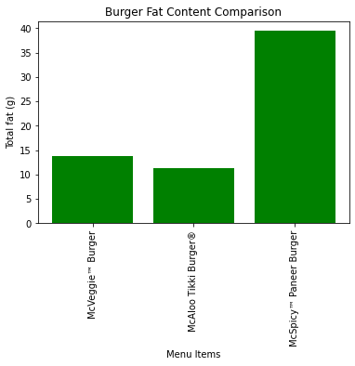

From the bar graph it is easy to view that the McSpicy Paneer Burger has the highest amount of Total fat content. For considering a choice from only these three items from the menu, a customer desiring a less the least amount of total fat content, would be the McAloo Tikki Burger.

Below is a bar graph comparison of Carbohydrate to Protein Ratio for McVeggie Burger, McAloo Tikki Burger, McSpicy Paneer Burger:

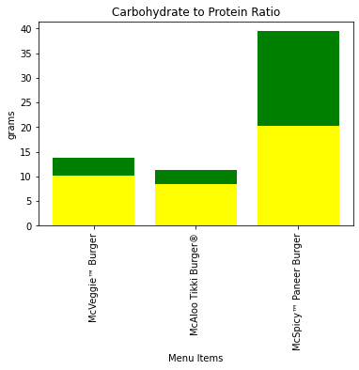

This bar graph takes into account the ration of carbohydrates to protein. In some cases, there are individual who have a diet choice to eat more protein than carbohydrates. For this diet choice a person who desires this type of diet would probably want to stay away from the McSpicy Paneer Burger. From the graph it can be viewed that the McSpicy Paneer Burger has an equal ration of protein to carbohydrates.

Even though it looks like McVeggie Burger and the McAloo Tikki Burger have similar ratios of protein to carbohydrate, the MCVeggie Burger has the highest amount (or more grams) of protein per serving.

Bar graph of Total fat, Protein, Carbohydrates, and Sugar for McVeggie Burger, McAloo Tikki Burger, McSpicy Paneer Burger:

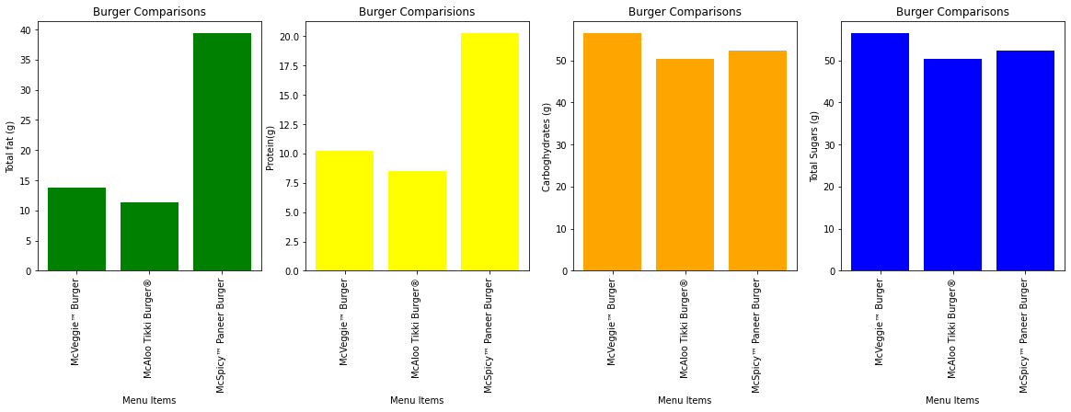

For overall comparison, the McAloo Tikki Burger is lowest in all categories. Even though the McSpicy Paneer Burger has a large amount of total fat and protein, the McVeggie Burger has the highest amount of sugar (g) and carbohydrates. Individuals who are worried about sugar and carbohydrate intake might take this observation into account when making a food choice from this menu. If a customer would desire to order and item choice of less carbohydrates and sugars from these three options; it would seem that the McAloo Tikki Burger is a better choice and has the least amount of sugar and carbohydrates per serving.

In a different view point, a customer may want an alternative the McSpicy Panner Burger and view the Spicy Panner Wrap as a compatible option.

Below is a percentage comparison between the McSpicy Paneer Burger and the Spicy Paneer Wrap:

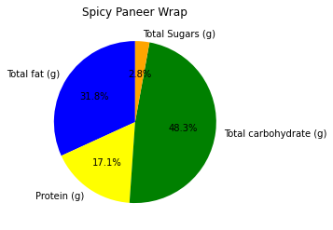 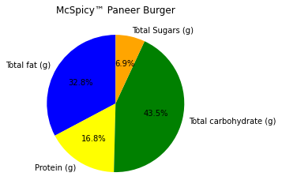

In considering that one is choosing between the Spicy Paneer Burger and the Spicy Panner Wrap this graph show that the options are very close in caparisons with the specific data being analyzed. In view it can be observed that the Spicy Panner Wrap has less sugar. Between the Spicy Paneer Wrap and The McSpicy Panner Burger, the option of the Spicy Paneer Wrap might be a better choice for a person who is viewing sugar content to make their own personal decision for this item choice.

Overall, there are individual who would like to make their own personal decision when choose an item menu. Some individual may look at other nutritional content other than those viewed in this analysis. The ability to view the content of food can help individuals make a better choice that suits their diet or their lifestyle choices.